**SIM808 Module GPRS SMS Development Board IPX SMA with GSM GPS Antenna**[**Instruction: Click to open**](http://files.banggood.com/2016/06/SKU405356-SIM808.zip) **Program provided (STC12/15/89, STM32 series):**  
  
Make a call  
Answer the phone  
Send text format SMS  
Send Chinese SMS  
Receive SMS control LED light  
GPRS_TCP program (dynamic IP)  
GPRS_TCP program (domain name)  
GPRS_UDP program (dynamic IP)  
GPRS_UDP program (domain name)  
GPRS transparent transmission mode program  
Comprehensive functional demo program (STM32)  
Comprehensive functional demo program (STC12)  
Comprehensive functional demo program (STC15)  
Bluetooth test program (PPS service, Bluetooth serial)  
Bluetooth phone control LED light  
GPS test program  
  
**Feature:**  
  
Power supply: 5-26V  
When the power supply is less than 9V, needs 2A DC  
Another channel power supply port is 3.5-4.2V, suitable lithium battery  
Computer debugging USB - TTL  
1 channel TTL serial port, can switch GPS and GSM function  
Can realize GPS positioning, messaging, data and other functions, the average standby at 80MA  
Power consumption is about 10MA  
With voice and microphone interface  
Quad Band, globally available  
  
  
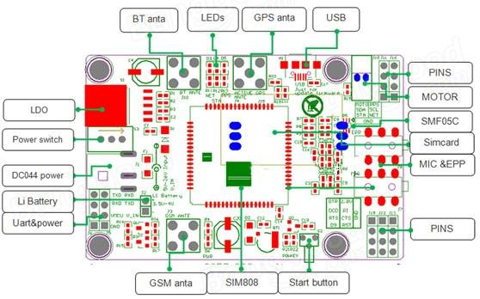  
  
1 channel GPS antenna interface, SMA interface for connecting an active antenna (default), you can also access the passive antenna  
1 channel GSM antenna interface, SMA interface  
1 channel Bluetooth antenna interface, SMA interface  
1 channel voice interface, 1 channel mic interface  
1 channel efficient LDO power supply, input voltage is 5-26V. Note that when the input voltage is less than 9V, please ensure that the power supply can provide current 2A. Another channel power supply input port 3.5-4.2V (suitable for lithium battery)  
1 channel TTL level interface, perfectly compatible with 5V, 3.3V, 2.85V level system  
1 channel USB interface, allows easy updates to SIM808  
Important chip pin all leads out  
  
The module basic through the serial port to send AT commands to achieve control, use this module only requires a power supply and a serial port.  
**Control module method:**  
  
  
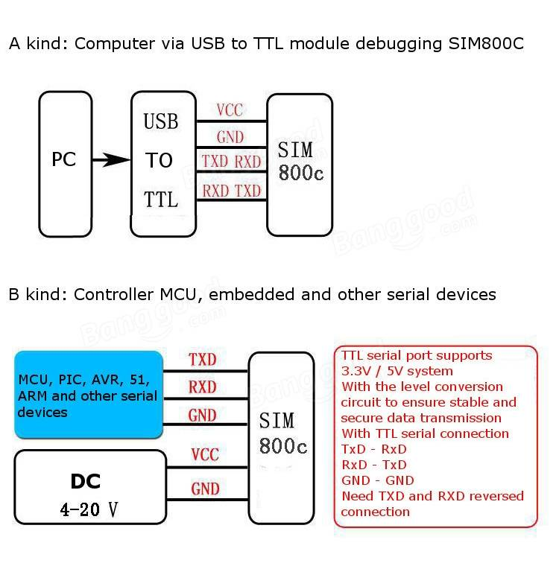  
  
**Introduction to use:**  
  
Insert a SIM card  
Insert the GPS antenna, GSM antenna, Bluetooth antenna (according to your own choice of applications to connect the antenna)  
When using computer debugging, connect the USB-TTL module; when using SCM control, please connect to the microcontroller serial  
Power on adapter  
Long press (about 2 seconds) Start button  
Ready to start debugging  
  
**Package includes:**  
  
1 x SIM808 Module  
1 x GSM antenna  
1 x GPS antenna  
  
  
